MS Teams Bot

Azure Bot Framework is used to create the bot. The Bot is deployed in AWS lambda and accessed via API exposed by AWS Api Gateway. The bot is registered to Azure Bot Service as mentioned [here](https://docs.microsoft.com/en-us/azure/bot-service/bot-service-quickstart-registration?view=azure-bot-service-3.0).

**Setup the Bot:**

Prerequisites

1. Code editor
2. Node Js
3. Git
4. [Bot Framework Emulator](https://github.com/microsoft/BotFramework-Emulator/blob/master/README.md) (Needed when running locally)
5. [Ngrok](https://ngrok.com/download) (Needed to test remote bot from local in Bot Framework Emulator)

Run the application locally

1. Set MicrosoftAppID and MicrosoftAppPassword as “” in launch.json
2. Run the application locally and observe the port no (say 5000)
3. Start Bot Framework Emulator and click Open Bot. Fill the form as shown below and hit connect  
   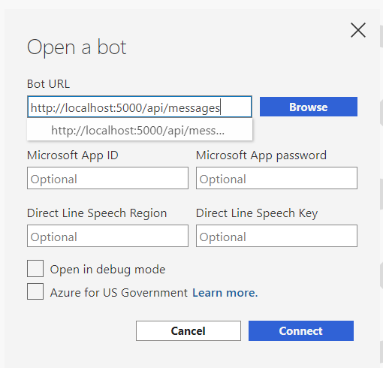
4. Start chat to continue the conversation

**Setup deployment process for the Bot:**

Bot is deployed in aws lambda and accessed via api gateway. Setup lambda and the api gateway either via console or cloudformation templates. Api url will be needed while registering the Bot.

**Register your web service with the Azure Bot Channel:**

Register the webservice via Azure Portal as mentioned [here](https://docs.microsoft.com/en-us/microsoftteams/platform/bots/how-to/create-a-bot-for-teams#with-an-azure-subscription). Create a new app registration and generate a client secret for the same which will be useful while registration.

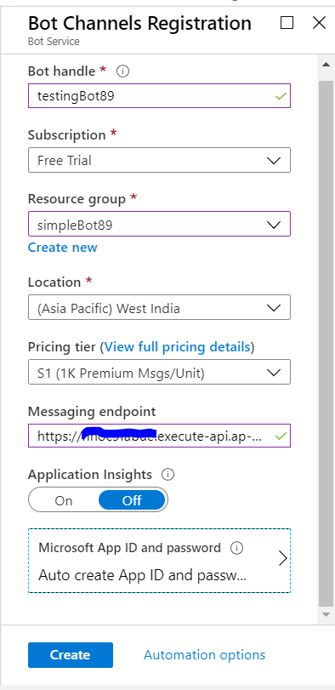

**Test your webservice:**

Test from Azure Console

Test using Emulator from local